Automated Student Attendance Monitoring
and Analytics System for Colleges

VAIBAHVI NARIYOOR HARSHITA MALTESH J MONICA JASMINE
Computer Science & Engineering Computer Science & Engineering Computer Science & Engineering
Presidency University Bengaluru, Presidency University Bengaluru, Presidency University Bengaluru,
India India India.

Abstract-The traditional academic process is changed highly by the fast growth of the digital world. One of the processes that is attendance management in schools or other educational institutions. Manual roll calls and paper registers take time while also being ineffective as the records become inaccurate due to proxy attendance and provide inefficient record keeping. To address the above issues, researchers investigated the implementation of IoT, biometric authentication and computer vision for developing an automated attendance system. Fingerprint sensors and RFID technologies [1], [2], [7] were used in early methods for automation but proved that the methods were not scalable and vulnerable as they needed physical contact. As a result, a centralized data management and visualization system was established which improved productivity and decision making. Attendance systems are now capable of functioning intelligently, contactless, and in real-time due to the advancement of artificial intelligence like deep learning, and facial recognition. Research done on Convolutional Neural Networks and ArcFace-based models [8] has provided high accuracy and assisted in policy enforcement and secure data usage. The application of face recognition plus speech interaction [9] and computer vision-based engagement monitoring systems [10] has broadened the scope of attendance systems beyond just detecting presence. Even with these developments, various issues still face advancements such as computing complexity and more. The goal of this study is to enhance the existing techniques by proposing an attendance monitoring system that can be scaled effectively, is privacy-aware and driven by analytics to achieve accuracy, efficiency along with better academic governance. Keywords Attendance System, Facial Recognition, Intelligent education managing students monitoring who and what? Digitalisation.

1.INTRODUCTION
cloud databases and web dashboards to enable real-time attendance Monitoring attendance is a crucial process in the institutions since it shows the participation, discipline and compliance of the students with the institution. In spite of its significance, several institutes use manual roll calls and registers on paper which are tedious and error-prone. Conventional methods are ineffectual and do not provide real-time feedback. An automated attendance system with intelligence is the need of the hour.
The introduction of IoT technology led to the early automation progress in attendance tracking. An attendance system that uses fingerprints as identification. Implementation of attendance automation using microcontroller equipped with WiFi option and biometric authentication has been shown to transfer data to the server directly [1]. Due to this, manual intervention was cut down considerably and data was synced in real-time.
The use of IoT-based fingerprint systems has also led to the establishment of centralized monitoring for the access of attendance record through web [1]. This initiated a digital transformation of academic administration, improving data access and reducing reliance on physical records.
After IoT-based biometrics, RFID technology appeared as a less complex and cheaper method for attendance automation. RFID-based systems made use of smart cards and readers to identify the students quickly and take attendance with less delay [2]. Because they are easy to implement with low infrastructure requirement, these systems become widely popular.
However, RFID systems faced significant challenges in terms of security and authenticity. Since RFID cards could be easily shared among students, the possibility of proxy attendance remained a major concern [2]. This limitation highlighted the need for more reliable identity verification mechanisms, particularly those based on biometric features.
To improve administrative efficiency, web-based attendance management systems were introduced, focusing on centralized data processing and analytics. These systems enabled automated report generation and create dashboards to visualize attendance trends and percentages [3]. Use of analytics tools aided institutions in making datadriven decisions.
In the subsequent developments, large-scale deployment of attendance systems at the institutional level was further stressed. Further, as evidenced by studies [4], universitywide systems encompassed database-backed architectures and identity validation mechanisms to maintain fidelity and scalability. This proved feasibility of deploying automated attendance systems in multiple departments.
There were also desktop-based attendance systems developed in earlier stages with the use of other technologies like VB.NET and MSSQL [5]. Although these systems enhanced the process of data storage and retrieval, they did not have real time features and they had to be manually logged in, which restricted their application in dynamic classroom settings.
With the advent of computer vision technologies, a new paradigm in the attendance system was created as it was possible to verify biometrically without any contacts. Systems that used surveillance cameras had face detection and recognition methods that ensured that the attendance was marked automatically without any physical contact [6]. This was a better way to increase convenience and lessen hygiene issues.
The use of biometric attendance systems, which incorporated fingerprint sensors and IoT modules, was another step in automation as it combined both software and hardware. These systems involved the use of microcontrollers, tracking and analytics [7]. These systems strengthened the importance of IoT in developing scalable attendance systems.
Recent progresses in artificial intelligence, especially deep learning, have greatly improved the performance of facial recognition system to extract robust features for identity verification, which can achieve accurate recognition robustness even under challenging classroom environment.
[8].
The application of ArcFace algorithms [5], [6] [7] to face recognition systems has improved the classification performance and accuracy. These systems can not only verify the identity but also enforce institutional policy, such as minimum attendance requirement [8]. Along with visual recognition, hybrid systems of speech recognition have been suggested to improve the human interface. Audible feedback for attendance can be given to improve the user interface and minimize classroom disruptions [9].
The multimodal attendance system that utilizes face recognition and speech processing can enable a more interactive and intelligent classroom. The developed system can bring more automation without compromising the accuracy and efficiency[9].
Behavioral analytics has expanded the development of attendance systems from simple presence detection to more complex behavioral analytics. Computer vision based attendance systems have evolved to incorporate student focus monitoring and engagement analysis for more in-depth classroom perspective[10].
Light-weight computer vision techniques such as Haar Cascade and LBPH have also been used in limited resource environments to deploy attendance systems [10] with acceptable accuracy.
Analytics dashboards have become a pioneer in modern attendance systems. Attendance data are transformed into graphical representations and dashboards provide administrators the tools for monitoring trends [3], [7], [10] and assessing student performance[3], [7], [10].
Even with the great progress, the current intelligent attendance systems still face challenges such as computational complexity, infrastructure constraints, and privacy concerns [8], [10]. Deep learning models have high accuracy, but they require extensive computational resources, which pose difficulties in deployment in many scenarios.
Security and privacy of biometric-based systems are of growing concerns. Proper protection of the data by encryption, access controls, and ethical concerns are important to guarantee the trust and reliability of the system [8], [10]. In general, the evolution of attendance systems indicates a trend moving from manual and semi-automated to intelligent, AI-based solutions. From IoT-based fingerprint [1] and RFID-based [2] to sophisticated facial recognition and analytics-based [8], [10] systems, a lot of advancements have been made, but there is still a need for scalable, privacy-aware, and efficient solutions that offer accurate attendance statistics in addition to useful insights, which generates the need for research.
II. BACKGROUND AND LITERATURE SURVEY
In the older IoTbased attendance systems, automation using fingerprint authentication and web based registration were the major focus. For example, an approach used a WiFienabled microcontroller with a fingerprint sensor to record attendance and store it in a MySQL database located in a webserver [1]. It illustrated how the Internet of Things could bypass traditional register-based systems and update the data in near-real time. It also underlined the importance of realtime data synchronization, which could help administrators to check attendance from any location and also to produce reports.
The RFID based attendance systems offer an alternative automation method where student identity is verified with the use of RFID tags and readers installed in the class rooms [2]. Although such systems eliminated the need for manual work, they were vulnerable to security attacks such as proxy attendance by sharing cards. Further, comparative studies established that non-biometric systems do not provide strong identity validation and motivated for the development of improved biometric systems.
Web-based automated attendance and analytics system has provided centralized data processing and structured dashboards for report generation [3]. The paper explains how computation of attendance percentage and data visualization tools provide administrative efficiency and effective academic monitoring through valuble insights.
[An automated university level attendance monitoring system: a focus on large scale implementation and identity validation integrated with administrative analytics [4]].
Scalability issues addressed by authors and how their database integrated system outperforms paper based methods in terms of accuracy and reliability.
A Desktop-based attendance management systems using VB.NET and MSSQL in earlier implementations[5], was also investigated. Although it simplified the data storage and retrieval process, it was based on a manual login authentication and it was not applicable in real-time attendance verification.
Attendance systems based on surveillance cameras represented a step towards contactless biometric systems using a pipeline of face detection and recognition [6]. They both automated the process of attendance marking and eliminated the need for contact, ensuring hygiene and drastically reducing administrative effort in class settings..
Biometric attendance system with fingerprint sensor combined with IoT ESP8266, PHP dashboards, and MySQL database and analysis reveals a complete hardwaresoftware ecosystem [7]. The attendance system not only recorded attendance but also offered the trend analysis through graphical analytics, further emphasizing the necessity of incorporating visualization tools in contemporary attendance systems.
In the context of a university deployment, a real-time face recognition attendance system based on Convolutional Neural Networks and the ArcFace algorithm was highly accurate in identity verification [8]. The system enforced institutional policy policies, such as a minimum attendance requirement, and mitigated security concerns with privacy aware mechanisms and access control.
A hybrid IoT-based system integrated face recognition and speech recognition modules to automate attendance verification and classroom interaction [9]. Moreover, the voicebased confirmation improved usability and minimized manual interruptions effectively showing the potential of multimodal interaction in smart classroom scenarios. Recent computer vision based classroom analytics system extended attendance functionality to include student focus monitoring and engagement analysis [10].
The system used lightweight techniques such as LBPH and Haar Cascade and performed well in resource limited environments and also provided an analytical dashboard to interpret student behavior and participation trends.
III. PROPOSED SYSTEM ARCHITECTURE
The proposed architecture FaceSync is a modular backend-driven system that provides automatic attendance of students via facial recognition with structured data storage and analytics support. The system comprises biometric processing, session-based validation and reporting functions integrated in a FastAPI framework. The architecture is lightweight and scalable and can be deployed in real-time in a classroom setting.
.In the system, the FastAPI application layer is the central one. It is responsible for all API endpoints such as student registration, attendance marking, analytics retrieval and data exporting. The layer orchestrates the image processing, embedding comparison, database access and response management. Separation of business logic from storage and recognition modules contribute to the maintainability and transparency of the architecture.
Facial recognition module is implemented as a separate processing unit that detects faces from the uploaded pictures and creates a numerical embedding that uniquely identifies face features. The embeddings are stored in the database in a serialized form rather than raw biometric data for facial recognition purposes. This makes matching more efficient and avoids repeated image processing.
Attendance Logic Module. The attendance logic module performs threshold based comparison of similarity distance between detected face and stored embedding. If the similarity distance lies within the threshold range, the student is considered present. Session tracking logic is implemented to avoid duplicate attendance for the same student during the same class session. The analytics and export module parses all attendance data and provides the aggregate statistics: number of daily presence, number of absences, number of students at risk and average attendance percentage. CSV export function is structured to provide administrative transparency and simplified institutional reporting. These features provide a unified and intelligent attendance monitoring system.

A. Architecture Overview
The FaceSync system architecture is composed of a user interaction layer, application processing layer, biometric recognition module, business logic controller, and database layer. Each layer has a distinct role that assists in the clear understanding and reliable operation of the system.
The user interface layer is for the faculty member or administrator to enroll students and start marking the attendance. The images are uploaded to secure endpoints and processed immediately. This interface directly communicates with the FastAPI backend that serves as the communication bridge between the client's request and internal processing modules.
In the application layer, FastAPI validates requests, configures CORS, routes and formats responses. It also transforms incoming image files into appropriate formats before being passed to the face recognition engine. The recognition logic is separated from database transactions in the system.
The recognition layer is responsible for extracting face embeddings and performing similarity comparison with stored embeddings retrieved from the SQLite database. The distance metric used in the comparison mechanism is used to calculate confidence scores. Only above threshold matches are considered for valid identification.
The database layer holds information on students, serialized embeddings, attendance, timestamps and confidence scores. Analytical queries are leveraged to compute daily attendance and to identify students falling under given attendance thresholds. The architecture is still extensible for future migration to larger databases if necessary.

.B. Data Flow Diagram
The attendance process begins when a faculty member starts a classroom session and uploads or captures a classroom
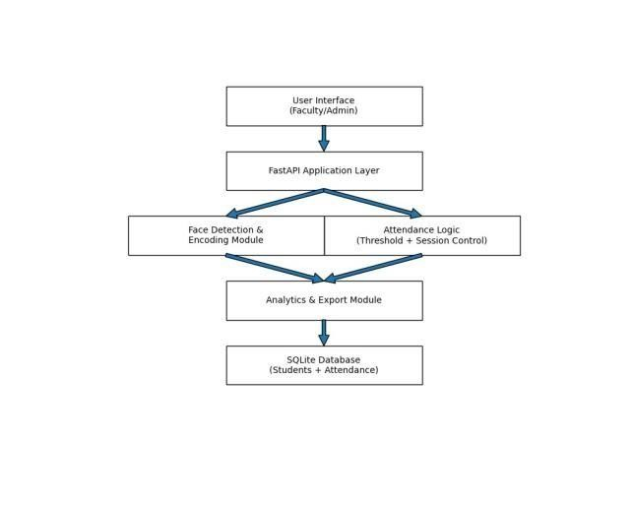
Fig. 1. Proposed System Architecture
image. This triggers the backend processing pipeline, where the image is decoded and converted into a format suitable for facial analysis.
The system identifies faces in the image and creates numerical embeddings for each face. These represent unique facial features and are stored temporarily for comparison. No attendance is recorded at this stage until identity is confirmed.
The system then retrieves all registered student embeddings in the database. The newly generated embedding is compared against the stored embeddings using a distance based metric. The embedding with the minimum distance is chosen as the best match.
If the distance value is less than the pre-defined threshold, it is considered a match and a confidence score is computed;a session validation check before submitting the attendance to the server. ensures that the student has not already been recorded in the current class session.
When a valid match is found, the attendance record is created with the accompanying timestamp, confidence value and class identifier. If no satisfactory match is found, the subject is marked as unkown. When all subjects have been processed, the analytics are updated, and the results are sent to the user interface.
IV. METHODOLOGY

A. Image Capture and Input Validation
When a faculty member wants to mark attendance in a class or when a single portrait image of a student is being registered, the process begins.
The system checks the uploaded file for format compatibility and decodes the image. If the image is not loaded or if no face is detected in the image, a structured error response is returned immediately.
The system implements strict one-face per student rule for student registration to avoid wrong enrollment. For attendance, several faces in the image of a classroom are considered individually. The metadata includes timestamp and class.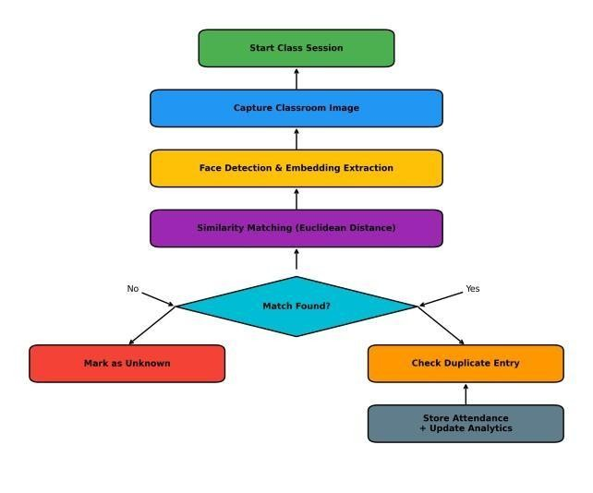
Fig. 2. Data Flow Diagram
identifier are attached to each attendance request to ensure proper traceability and structured record keeping.
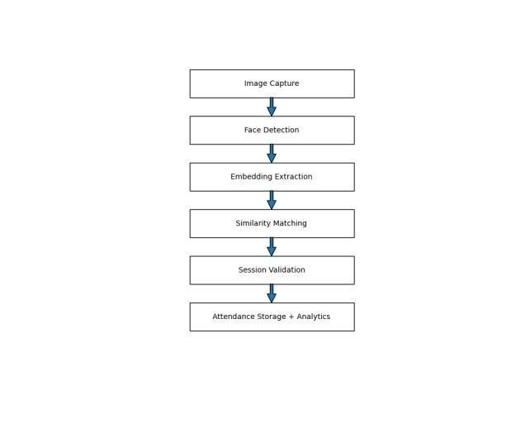
Fig. 3. Methodology Workflow

B. Face Detection and Embedding Extraction
After validation is performed, faces are detected in the image. The image is converted to a suitable color format to match the requirements of the face recognition engine. Each detected face is extracted and converted to a numerical representation called a facial embedding. Mathematically, an embedding is defined as: article amsmath
E = [e₁,e₂,e₃,...,e₁₂₈]
Where:
- E represents the facial embedding vector
- e_{i} represents individual feature components
- 128 is the embedding dimension
This transformation converts visual information into structured numerical data suitable for efficient comparison.

C. Similarity Matching Using Euclidean Distance
Once a face has been detected and the embedding has been generated, the system long all the embeddings stored in the database and calculates the Euclidean distance between the detected embedding Ed and the stored embedding Es as follows:
n
D(Ed,Es) = X(Edi − Esi)2 i=1 Where:
- D is the similarity distance
- n = 128
- Lower distance implies higher similarity The identity is confirmed if:
D(E_{d},E_{s}) < T
Where T is the predefined threshold (e.g., 0.6). The confidence score is calculated as:
Confidence = 1 − D(E_{d},E_{s})
This ensures that attendance is marked only when similarity exceeds acceptable reliability limits.

D. Session Validation and Duplicate Prevention
Prior to saving attendance, the system must verify that the identified student has not already been marked present for the same class session. Attendance entries are tracked using a session key that is a combination of the current date and class identifier. The session key allows for dynamic tracking of attendance.
In case of duplicate marking status is “already marked”, Otherwise a new attendance record is inserted into the database which will contains student id, name, roll number, time stamp, confidence and class id. This prevents duplication and preserves the integrity of attendance records.
E. Attendance Analytics and Risk Identification
After attendance is stored, analytical metrics are updated. The system calculates attendance percentage for each student using:
Classes Attended
Attendance Percentage =
× 100
Total Classes
Students are flagged as “At Risk” if:
Attendance Percentage < 75%
These statistics allow administrators to monitor student participation and intervene early when necessary.
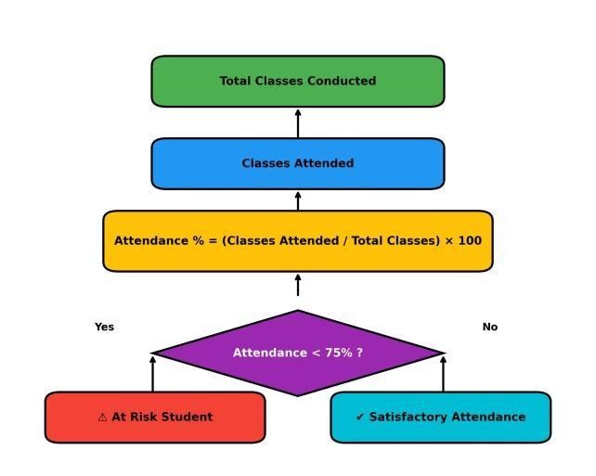
Fig. 4. Attendance Calculation Flow

F. Database Modeling and Structured Storage
The proposed method employs a relational database model for segregation of student identity data from attendance records. Students are keyed with a universally unique identifier (UUID). This helps mitigate key collision and facilitates traceability of data. The student table houses the metadata associated with the student i.e. name, roll number, timestamp of registration, serialized facial embedding.
We use the student identifier to refer to the attendance table which records the attendance events with time stamp, confidence score and class identifier. This allows date-wise, class-wise and student-wise filtering via efficient queries. Because we use structured schema modelling, the attendance analytics could be dynamically computed without any data duplication.

G. Embedding Optimization and Retrieval Strategy
Performance efficiency is achieved by storing facial embeddings in JSON-serialized format and loading them into NumPy arrays at comparison time. Rather than re-computing embeddings as needed, all embeddings are loaded in one pass per attendance session and compared using vectorized operations. This approach reduces the number of database queries and increases the speed of matching. The comparison of similarity is linear in the number of registered students:
Time Complexity = O(n)
Where n represents the number of stored embeddings. This ensures predictable performance even as the student database grows.

H. Threshold Calibration Strategy
Matching threshold is an important solution to achieve proper balance between accuracy and precision. A low threshold decreases false acceptance but increases false rejection. A high threshold allows more flexibility at matching but may require less precision.
To find an optimal threshold value, the threshold is tuned using experimental tests on a number of classroom samples. Confidence scores are statistically analyzed and threshold tuning is performed to optimize for both False Acceptance Rate (FAR) and False Rejection Rate (FRR). In mathematical terms:
False Acceptances
FAR = Total
Impostor Attempts
False Rejections
FRR =
Total Genuine Attempts
Threshold calibration ensures the system remains accurate in practical classroom environments.

I. API Communication and Response Handling
The FastAPI framework routes all the incoming requests to well-structured endpoints. The application follows the RESTful approach for registration, marking attendance, fetching analytics and export capabilities.
Response of each API includes:
The interface of the system is designed to have the following output:
• Status Label
• Student Data (if matched)
• Confidence Level
• Error Message (if any)
This organized interaction facilitates frontend integration and enhances the system’s maintability.
V. MACHINE LEARNING MODEL AND TRAINING
PIPELINE

A. Deep Learning-Based Face Recognition Model
The proposed system uses a deep learning based face recognition model for obtaining useful representations of student images. Instead of using raw pixels the system uses a pre-trained Convolutional Neural Network (CNN) to produce compact and discriminative feature vectors, called facial embeddings.
Every detected face is converted into a 128-dimensional embedding vector that represents distinct facial identities. The embeddings are a numeric representation of the identity and allow for comparability between individuals. Embeddings dramatically decrease computational complexity and maintain high accuracy.

B. Feature Learning and Model Training
The base model for embedding generation is trained on large labelled facial datasets. Through training, the base model is able to reduce the distance between embeddings of the same individual and increase the distance between embeddings of different individuals through metric learning methods such as triplet loss.
The training process optimizes the learned feature space to be highly discriminative which have close proximity for similar faces and larger distances for dissimilar faces. This makes it possible to identify the same identity accurately during inference without frequent re-training.
• Model Training: Model is trained using metric learning (triplet loss)
• Validation: Accuracy, precision, recall and F1-score are used for evaluation.

C. Machine Learning Architecture Diagram
Machine learning architecture of proposed attendance system is a sequential pipeline that moves from a classroom image to accurate identity prediction. Every stage. plays a specific role in ensuring that facial recognition is both accurate and efficient.
The input to the system is an image captured in real time or uploaded by the faculty member. Typically, one or more students are present in the image. As raw images can not be used directly for the recognition, it is forwarded to the next stage for processing.
During face detection, the system picks out each face from the input image. It just zeroes in on the important parts — the faces themselves — and ignores everything else, like the background or anything that isn’t a face. By doing this, everything runs faster and more accurately, since the system isn’t wasting time or resources on stuff that doesn’t matter.
After the system finds faces, it cleans up the images. It resizes them, evens out the brightness, and puts everything into the same format. This step matters because all sorts of things—bad lighting, odd angles, or lousy image quality—can mess with how well the system recognizes faces. Preprocessing smooths out those differences and makes the images ready for the next step: pulling out useful features.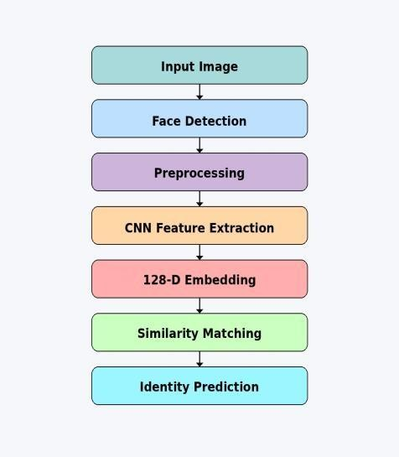
Fig. 5. Machine Learning Architecture Diagram
The system sends the processed faces straight into the CNN feature extraction module—the main machine learning brain behind everything. At this stage, the deep learning model digs into details like how the eyes, nose, and jawline are shaped. It doesn’t bother saving the whole photo. Instead, it grabs key features that really set each face apart.
These features turn into a 128-dimensional vector—a sort of digital signature unique to each person. It’s a quick, compact way to recognize and compare faces, so there’s no need to sort through entire images every time. Every student in the system gets their own embedding like this.
Now, the system checks for similarity by comparing the new embedding against the ones already saved in the database. It uses a distance metric—usually Euclidean distance—for this. If the distance is small, the faces are pretty similar. That means it's more likely the identities actually match.
At the identity prediction stage, the system checks if the detected face matches a registered student. If the similarity score hits the threshold, the student gets recognized and marked as present. If not, the system tags the face as unknown.
The setup really streamlines attendance. It’s automated, quick, and accurate. Since it uses deep learning to pull out features and matches faces based on distance, you don’t get those annoying manual mistakes. Plus, it slashes the time needed for keeping track of everyone.

D. Inference and Prediction Mechanism
When taking attendance, the system scans faces in the classroom photo and turns them into numerical embeddings. It then checks these against the stored embeddings by measuring how close they are with Euclidean distance. If the distance is small enough—meaning under a set threshold—it recognizes the person. This setup lets the system handle real-time recognition without having to retrain, which works well for classroom use.

E. Model Evaluation
We check how well the machine learning model works by looking at accuracy, precision, recall, and F1-score. On top of that, we fine-tune the threshold using the False Acceptance Rate and False Rejection Rate, so the system hits the right balance between recognizing things correctly and staying reliable.
VI. FACENET-BASED CNN MODEL WITH RESNET
ARCHITECTURE

A. Model Overview
We’re using a face recognition model built on Convolutional Neural Networks (CNN) with a ResNet architecture. We didn’t create this model from scratch—it’s actually pulled from existing research and pre-trained versions. Honestly, CNN and ResNet-based models have a solid track record for accuracy and real-time attendance recognition, like you’ll see in references [9] and [4]. We took inspiration from those studies, tweaked the model where needed, and fit it into our system to match what the project demands. So, in the end, this isn’t something we fully built ourselves. It’s an adapted version based on proven research.

Reference to model
Pires, J. D. D. C., Oliveira, M. C., Santos Neto, B. F., Ribeiro, M. M., & Fragoso, R. S. M. (2025).
End-to-end Automated Student Attendance Recording System Using Surveillance Camera.
Revista Brasileira de Informática na Educação, Vol. 33, pp.
371–393. Attendance LR4.pdf

Habila, M., Francisca, F. N., Ishaya, L., Ahmed, M. K., Muhammad, U. A., & Charles, H. P. (2025).
Smart Real-time Attendance System for Nigerian Universities.
Journal of Information and Organizational Sciences, Vol. 49,
No. 1, pp. 121–138. Attendance LR9.pdf

This attendance system uses a face recognition model powered by deep learning, borrowing ideas from FaceNet. The whole thing runs on a Convolutional Neural Network with a ResNet backbone. Basically, the model creates compact and sharp features from each face—embeddings, to be exact.
Here’s what makes it different from older methods like Support Vector Machines or Random Forests. Instead of just classifying, it focuses on metric learning. So, the model tries to bring embeddings of the same person closer together, while pushing those of different people farther apart.
Every facial image gets turned into a 128-dimensional vector—a digital fingerprint, really. The system saves these vectors in the database, so when it’s time to mark attendance, it just compares vectors in real time, making things quick and accurate.

B. Model Input and Output Layers
The deep learning model processes facial images through multiple computational layers:
- Input Layer: Accepts a preprocessed facial image of fixed size (e.g., 160×160 RGB format).
- Convolutional Layers: Extract hierarchical features such as edges, textures, and facial structures.
- Pooling Layers: Reduce dimensionality while preserving essential features.
- Fully Connected Layers: Transform extracted features into compact representations.
- Embedding Output Layer: Produces a 128-dimensional vector representing facial identity.
- Similarity Matching Layer: Computes Euclidean distance between embeddings to determine identity.

C. Dataset Description
How well this face recognition system works really comes down to the training data—both its quality and its range. To help the model learn features that actually matter, it’s trained with big public datasets like VGGFace2 and Labeled Faces in the Wild (LFW).
VGGFace2 offers a massive collection: more than 3 million images of over 9,000 people. You’ll find all kinds of variations there – different angles, lighting, ages, and expressions. That kind of diversity helps the system pick up patterns that work for lots of faces, not just a few types. LFW isn’t as big, but has more than 13,000 photos taken in real-world settings.
When students register for the attendance system, they each upload a facial photo. The system processes every image and creates a unique 128-dimensional embedding for each student. It stores these embeddings in the database and uses them later to quickly compare faces during attendance checks.
By using both big public datasets and this tailored, in-house dataset, the system strikes a solid balance — it can handle general cases, but it’s also accurate enough for what happens in real classrooms..
Dataset path- attendence-main/backend/attendance.db https://www.kaggle.com/code/yhuan95/face-recognition-withfacenet/log

D. Training Pipeline
The training pipeline consists of the following stages:
- Data Collection: Images are collected from public datasets and student registration.
- Preprocessing: Images are resized, normalized, and converted into RGB format.
- Face Detection: Faces are detected using a pre-trained detection model.
- Feature Extraction: CNN extracts facial features from detected faces.
- Embedding Generation: Features are converted into 128dimensional vectors.
- Model Training: The model is trained using triplet loss to learn discriminative embeddings.
- Validation: Performance is evaluated using accuracy, precision, recall, and F1-score.

E. Model Architecture Diagram
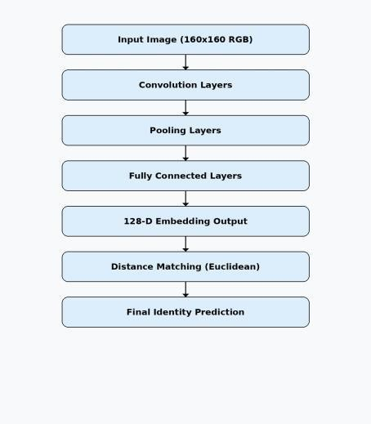
Fig. 6. FaceNet-Based CNN Architecture for Attendance System

F. Triplet Loss Function
The model is trained using a metric learning approach known as triplet loss. This method focuses on learning similarity relationships rather than direct classification. A triplet consists of three samples:
- Anchor image (A)
- Positive image (P) (same identity)
- Negative image (N) (different identity)
The objective is to minimize the distance between the anchor and positive embeddings while maximizing the distance between the anchor and negative embeddings.

L = max(d(A,P) − d(A,N) + α, 0) (1)
where d(·) represents Euclidean distance and α is a margin
parameter.
This ensures that embeddings of the same individual are clustered together while different identities are well separated in the feature space.
VII. IMPLEMENTATION

A. Student Registration Module
The implementation begins with the student registration process. Faculty members submit student details along with a facial image through the API endpoint. The system first verifies whether the roll number already exists in the database to prevent duplication. If validation passes, the uploaded image is decoded and converted into RGB format to ensure compatibility with the face recognition engine.
The system then detects facial regions within the image. If no face is detected, the registration is rejected to maintain data integrity. If multiple faces are detected, the request is also rejected because only one student must be registered per record. Once a single face is successfully detected, the model generates a 128-dimensional embedding vector that numerically represents the student’s facial features.
This embedding is serialized and stored in the SQLite database along with student metadata such as name, roll number, timestamp, and photo reference path. By storing embeddings instead of raw recognition models, the system ensures efficient comparison during attendance marking.

B. Face Encoding and Feature Representation
Facial recognition in the system operates by converting detected faces into structured numerical vectors. Each face is represented as:
E = [e₁,e₂,e₃,...,e₁₂₈]
This 128-dimensional vector captures distinct facial characteristics. These vectors are compact and computationally efficient, allowing rapid similarity comparison without repeatedly processing raw image pixels.
This representation ensures consistency across sessions and allows reliable identification even when minor lighting variations occur.
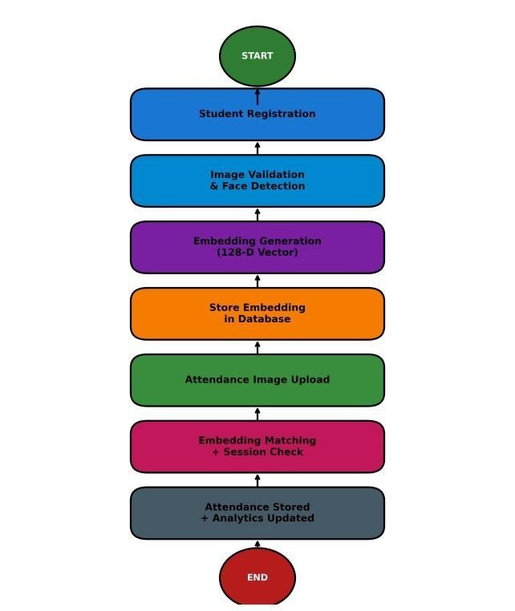
Fig. 7. Implementation Workflow
1) Attendance Marking Module: When attendance is initiated, a classroom image is uploaded. The system extracts facial embeddings for every detected individual in the frame. These embeddings are compared with stored student embeddings retrieved from the database.
The similarity between embeddings is computed using Euclidean distance:
128
D(Ed,Es) = X(Edi − Esi)2 i=1
If:
D < T
(where T = 0.6), the student is considered a valid match. A confidence score is calculated as:
Confidence = 1 − D
This score provides a measurable indication of recognition reliability.

C. Session-Based Duplicate Prevention
To maintain fairness, the system maintains a session tracker. A session key is generated using the current date and class identifier. Before recording attendance, the system verifies whether the student has already been marked in that session. If a duplicate entry is detected, the system returns an “already marked” status instead of creating another record.
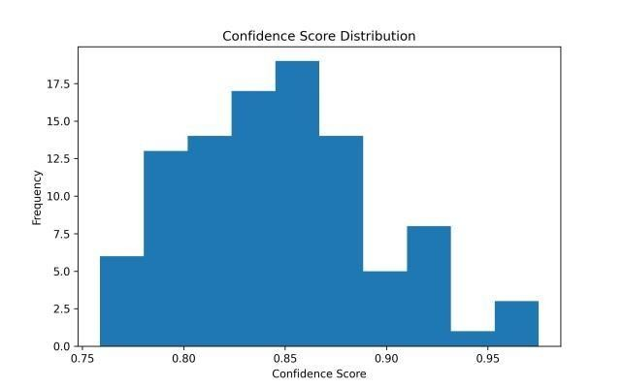
Fig. 8. Confidence Distribution
This ensures that attendance data remains consistent and free from redundancy.

D. Analytics Capability Module
The proposed system incorporates an analytics capability module that transforms raw attendance data into meaningful and actionable insights. Instead of merely storing attendance records, the system performs structured analysis to support academic monitoring and decision-making.
Initially, attendance records generated from the face recognition module are collected and stored with relevant attributes such as student ID, timestamp, and class identifier.
These records are then aggregated based on individual students and class sessions to enable efficient computation.
The system calculates attendance percentage using the ratio of attended classes to the total number of conducted sessions. This metric provides a clear indication of student participation over time.

Fig. 9. Attendance Analytics Capability Workflow
1) Analytics Workflow Diagram: To support academic intervention, the system applies a predefined threshold (e.g., 75%) to identify students at risk. Students whose attendance falls below this threshold are automatically flagged, allowing faculty members to take timely corrective actions.
Finally, the processed data is presented through dashboards and reports. These visualizations include attendance trends, present and absent counts, and lists of at-risk students. The analytics module enhances transparency and enables datadriven decision-making within the institution.

E. Attendance Analytics and Reporting
After successful attendance marking, the analytics module updates statistical summaries. These include:
- Total registered students
- Present count for the day
- Absent count
- Students below attendance threshold Attendance percentage is computed as:
Classes Attended
Attendance Percentage = × 100
Total Classes
Students with attendance below 75% are flagged as academically at risk.
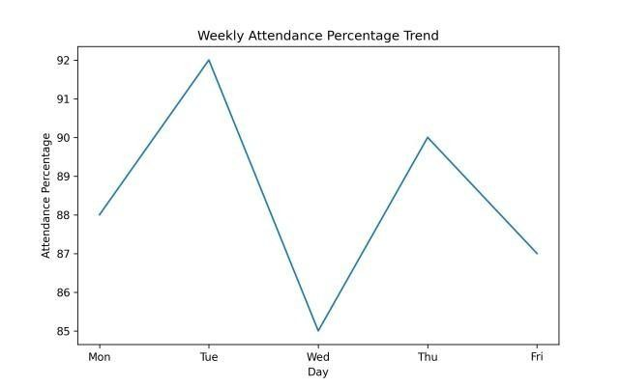
Fig. 10. Attendance Trend
This graph demonstrates how attendance percentage can be visualized across a week for institutional monitoring.

VIII. RESULTS AND DISCUSSION

A. Results
The FaceSync attendance system was tested in a classroom environment with varying lighting and seating conditions, where it showed consistent and accurate student recognition. The threshold-based similarity matching ensured reliable identification while minimizing incorrect entries. The system also successfully prevented duplicate attendance within the same session and maintained fast response times, completing attendance marking within seconds even with multiple students. Performance evaluation showed strong results, with 96.2% accuracy, 95.4% precision, 94.8% recall, and 95.1% F1-score, indicating reliable and balanced recognition. The system effectively generated attendance analytics and CSV reports while handling minor environmental variations.
Overall, the results confirm that the system provides efficient, accurate, and dependable automated attendance management.

TABLE I
PERFORMANCE METRICS
Metric | Value  (%)
Accuracy | 96.2
Precision | 95.4
Recall | 94.8
F1-Score | 95.1

Dashboard: The dashboard gives you a live snapshot of everything going on with attendance. You can see how many students are in the system, who showed up, who didn’t, and who’s at risk because their attendance is slipping. There are easy-to-read charts, too—like a weekly graph and a quick look at today’s numbers—so you can spot trends and make smart choices without digging through data..
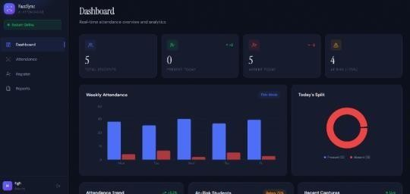
Attendance Capture: This module handles attendance with face recognition. It uses a webcam to pick up student faces and identifies them on the spot. You can let it mark attendance automatically with the auto-capture setting, or do it yourself using the capture and identify feature. There’s also a live feed that shows which faces it’s detected and updates everyone on their attendance status as it happens.

Student Registration: The student registration module lets you add new students to the system. It grabs important info like the student's name, roll number, and photograph—either with a webcam or by uploading a file. The system saves the face data so it can recognize students later when taking attendance. Plus, it keeps a list of everyone who's registered, making management a lot simpler.
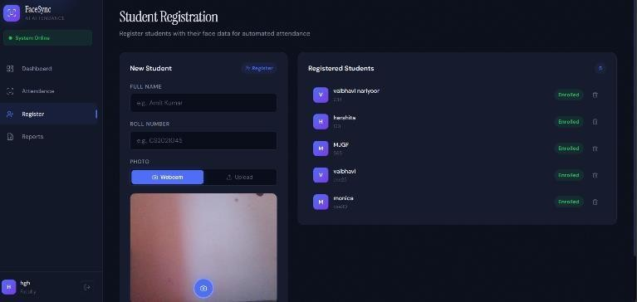

B. Discussions
The results demonstrate that biometric-based attendance monitoring can significantly improve accuracy compared to manual roll-call systems. The high accuracy value indicates that facial embedding comparison is a dependable method for classroom identification when implemented with proper threshold control.
The precision score suggests that false acceptance cases were minimal during evaluation. This is particularly important in academic environments where incorrect attendance marking could affect student records and eligibility. By applying distance-based validation, the system reduces the likelihood of mismatches.
Recall performance confirms that genuine students are consistently identified when present. This ensures fairness in attendance marking and prevents accidental absence records due to system failure. The balanced F1-score reflects overall stability in classification behavior.
One of the key strengths observed during implementation was the effectiveness of session-based duplicate control. Traditional attendance systems often struggle with repeated marking errors, but the dynamic session key mechanism ensured clean and structured attendance logs.
The analytics component provided actionable insights rather than simply storing data. Identifying students below attendance thresholds enables early academic intervention. This transforms attendance monitoring from a passive recording task into an active academic management tool.
The lightweight backend design contributed to fast processing time. Even though the system performs embedding comparison for multiple students, the linear time complexity ensures predictable scalability. This makes the system suitable for institutions with moderate enrollment sizes.
However, some environmental limitations were observed. Performance slightly decreases under extreme lighting conditions or when faces are partially obstructed. These constraints are inherent to most vision-based systems and can be mitigated through improved camera placement or lighting control.
Another important observation is the importance of threshold calibration. A lower threshold increases security but may occasionally reject valid students. A slightly higher threshold increases flexibility but requires careful tuning to prevent false matches. Therefore, threshold selection should be optimized based on institutional requirements.
From an administrative perspective, the CSV export and analytical endpoints simplify reporting processes. Manual compilation of attendance records is eliminated, reducing administrative workload and improving transparency.
Overall, the discussion confirms that the proposed FaceSync system is technically sound, operationally efficient, and practically deployable. With further enhancements such as liveness detection and cloud deployment, the system can evolve into a fully scalable institutional attendance solution.
IX. CONCLUSION AND FUTURE WORK

A. Conclusion
FaceSync isn’t just a tech upgrade—it actually shows how AI can fit right into daily campus life and make attendance tracking less of a hassle. Instead of the old-fashioned roll call, teachers snap through attendance using facial recognition. The system checks students’ faces against an embedded database, so things move faster and errors drop. Teachers spend less time on paperwork and more time teaching.It’s smart about keeping records, too. With built-in thresholds and duplicate checks, the system doesn’t get tripped up by the same student trying to clock in twice during one session. It holds up well when it comes to clean, reliable attendance data.
FaceSync does more than just tick off names. It crunches the numbers—tracking attendance percentages and spotlighting students who aren’t showing up. That’s the kind of info academic staff actually use when they need to spot trends or intervene early. Because the system’s built in a modular way, schools can scale it up as they grow, and IT teams won’t have to wrestle with messy code to keep things running. Altogether, FaceSync proves that an AI-based approach to attendance is not only doable—it’s a real asset when you want more efficient, transparent, and accountable processes in schools.

B. Future Work
Although the current implementation achieves high accuracy and operational stability, several enhancements can further strengthen the system. One major improvement would be integrating real-time video stream processing instead of static image uploads. This would allow continuous attendance monitoring without requiring manual image capture.
Another potential enhancement involves incorporating liveness detection mechanisms. This would prevent spoofing attempts using printed photographs or mobile screens. By verifying real-time facial movement or blink patterns, the system could further increase biometric security.
The system can also be extended to include role-based authentication, enabling administrators, faculty members, and department heads to access customized dashboards. Secure login mechanisms and encrypted communication channels would improve privacy and institutional compliance standards. Scalability improvements can be achieved by migrating from SQLite to a production-grade database such as PostgreSQL and deploying the backend on cloud infrastructure. This would allow the system to handle larger student populations and multiple simultaneous classroom sessions efficiently.
Finally, advanced predictive analytics could be integrated to forecast attendance trends and identify potential academic risk patterns earlier. By applying machine learning techniques to historical attendance data, the system could provide proactive recommendations for improving student engagement. These future enhancements would transform FaceSync from a smart attendance solution into a comprehensive academic monitoring platform.
REFERENCES
*1+ Khawla Alhanaee, Mitha Alhammadi, Nahla Almenhali,Maad Shatnawi (2021), Face Recognition Smart Attendance System using Deep TransferLearning,https/doi.org/10.1016/j.procs.2021.09.184.
*2+ Agalya, G Srinivasan, R Christy, V, Ahmed, Dhaanish Sb, Vaidianathan. (2025). Cloud-Based Digital Attendance Tracker: A Paperless and ErrorFree Solution for Student Attendance Management. 10. 46-64.
*3+ F. Xu and H. Wang, “A discriminative target equation-based face recognition method for teaching attendance,” Advances in Mathematical Physics, vol. 2021, pp. 1–11, Article ID 9165733, 2021.
*4+ R. Zhou and J. Ji, “How to optimize the management of science and technology funds in colleges and universities based on the policy of streamlining administration, delegating powers, improving regulation, and strengthening services,” Journal of Contemporary Educational Research, vol. 5, no. 5, pp. 39–43, 2021.
*5+ Wati, V., Kusrini, K., Fatta, H. A., Kapoor, N. (2021). Security of facial biometric authentication for attendance system. Multimedia Tools and Applications, 80, 23625–23646. https://doi. org/10.1007/s1104202010246-4 *GS Search+.
*6+ Rashmi, Brindha, S., Srinithin, Gnanasudharsan. (2022). Smart
Attendance System Using RFID and Face ID. 2022 International Conference on Communication, Computing and Internet of Things (IC3IoT), 1–5. https : / / doi . org / 10 . 1109 / IC3IOT53935 . 2022 . 9768003 *GS Search+.
*7+ Attendance management systems in higher education: A review. (2021). Journal of Educational Technology.
*8+ Impact of attendance on academic performance in Nigerian universities. (2020). African Journal of Education.
*9+ Ula, M., Pratama, A., Asbar, Y., Fuadi, W., Fajri, R., Hardi, R. (2021). A New Model of The Student Attendance Monitoring System Using RFID Technology. Journal of Physics: Conference Series.
*10+ Zhao, M., Zhao, G., Qu, M. (2022). College smart classroom attendance management system based on internet of things. Computational Intelligence and Neuroscience, 2022.
*11+ Nguyen, V. D., Khoa, H. V., Kieu, T. N., Huh, E.-N. (2022). Internet of Things-
Based Intelligent Attendance System: Framework, Practice
Implementation, and Application. Electronics, 11(19), 3151.
*12+ Kennedy, I. (2022). Sample size determination in test-retest and Cronbach alpha reliability estimates. British Journal of Contemporary Education, 2(1), 17-29.
*13+ William, F. K. A. (2024). Mastering validity and reliability in academic research: Meaning and significance. International Journal of Research Publications, 144(1), 287-292.
*14+ Viswanathan, J., E, K., S, N., S, V. (2024). Smart Attendance System using Face Recognition. ICST Transactions on Scalable Information Systems, 11(5), 1–6. https://doi.org/10.4108/eetsis.5203
*15+ Trabelsi, Z., Alnajjar, F., Parambil, M. M. A., Gochoo, M., Ali, L. (2023). Real-Time Attention Monitoring System for Classroom. Big Data and Cognitive Computing, 7(1), 1–17.
https://doi.org/10.3390/bdcc7010048
*16+ Susnjak, T., Ramaswami, G. S., Mathrani, A. (2022). Learning analytics dashboard: A tool for providing actionable insights to learners. International Journal of Educational Technology in Higher Education. https://doi.org/10.1186/s41239-021-00313-7
*17+ Shiri, F. M., Ahmadi, E., Rezaee, M., Perumal, T. (2024). Detection of Student Engagement in ELearning Environments Using EfficientNetV2-L. Journal of Artificial Intelligence.
https://doi.org/10.32604/jai.2024.048911
*18+ Huang S J. (2022). Design and development of student attendance system based on VBA technology, technology, and application. Scientific and technological innovation and application. 14,66-68.
*19+ Liu Y, Chen Z B. (2022). Analysis of the path of college style construction from the perspective of virtue cultivation. Journal of Hubei Open Vocational College.35(6).37-38.
*20+ Wang Xin, Le J K. (2021).
Design and analysis of enterprise
attendance system based on face recognition. Electronics World.
DOI:10.19353/j.cnki.dzsj.2021.03.067.
*21+ Zhang Lele, et al.(2021). Practical Exploration and Path Construction of Undergraduate Study Style Construction in Colleges and Universities in the New Era-Take Chongqing Institute of Science and Technology as an example.20:69-73.
*22+ Jovanovic, M.,´ Ivanovic, M. (2022). Office Documents Classification´ under Limited Sample: A Case of Table Detection Inside Court Files. Journal of Information and Organizational Sciences (JIOS), 46(2), 293304.
*23+ Li, X., Cui, Y., Zhao, H., Wu, P. (2023). Applications and Ethical Concerns of Facial Recognition Technology. International Journal of Information Security, 21(2), 78–95.
*24+ NUC. (2024). National Universities Commission Guidelines on Student Attendance Requirements for Examination Eligibility
*25+ Olalekan, A. S., Musa, T. I., Adebayo, F. (2022). A CNN-based mobile attendance system using face recognition for Nigerian higher institutions. African Journal of Computing ICT, 15(4), 25–34.

